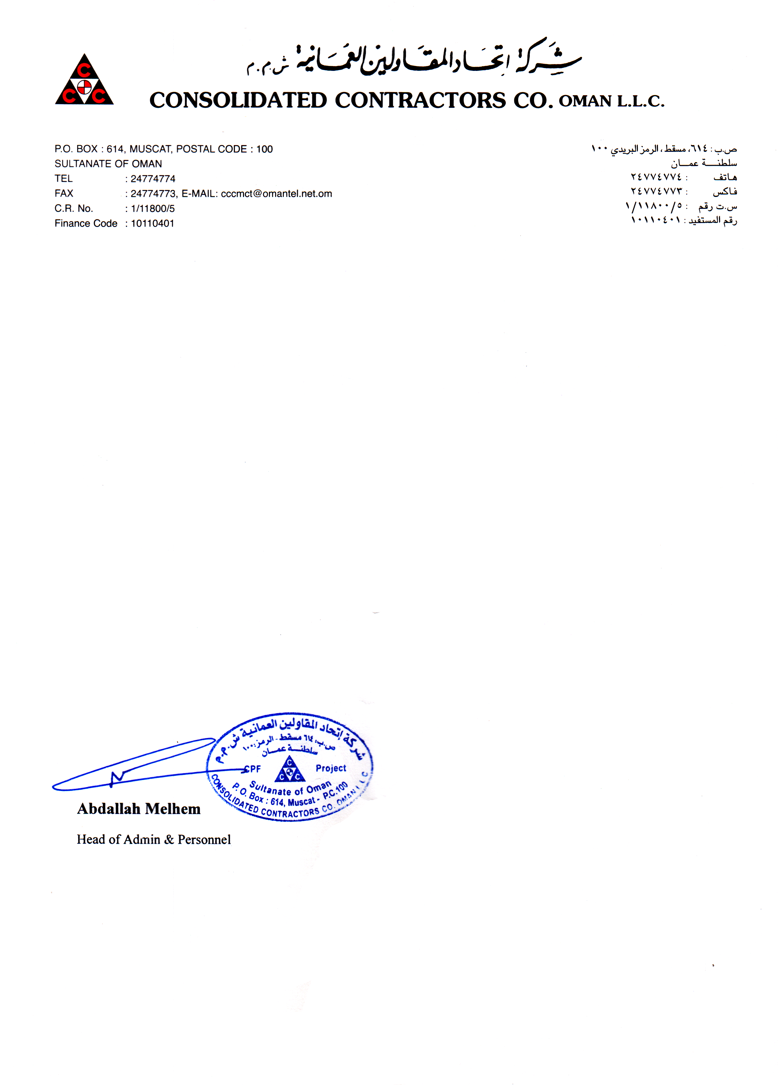

Ref: CPF/A&P/76106/ <To>

**TO WHOM IT MAY CONCERN**

This is to certify that Mr. <name> of Pakistani Nationality was in the employment of Consolidated Contractors Company LLC, from <From> up to <To> in the capaciy of “<Designation>” Oman

This certificate is issued upon his request without any obligation toward the Company.